CO 1 – R PROGRAMMING
LAB EXERCISES
COMPLETE SOLUTIONS
Course Code : ITA0407
Name: Kalahasthi Ramya
Register Number: 192311149
Department: BE. CSE

LAB EXERCISE SOLUTIONS

QUESTION 1
Question
Explore the R and RStudio environment before writing a program. Identify the console, script editor, environment/workspace pane, files pane and help system. Run a simple command, inspect the current R version and working directory, and open the help page for mean(). Record what each environment feature is used for.
Aim
To explore the RStudio interface, identify its main panes, and execute basic commands to inspect the R version, working directory and help documentation.
Algorithm
- Open RStudio and identify the Console, Source/Script Editor, Environment/Workspace, Files and Help panes.
- In the Console, execute a simple arithmetic expression.
- Use R.version.string to display the installed R version.
- Use getwd() to display the current working directory.
- Use help(mean) or ?mean to open documentation for the mean() function.
- Record the purpose of each interface pane.
Program
# Explore the R environment
2 + 3

# Display the installed R version
R.version.string

# Display the current working directory
getwd()

# Open help documentation for mean()
help(mean)
# Alternative: ?mean

# Display a short description of the interface areas
cat("Console: Executes R commands and displays results.\\n")
cat("Script Editor: Writes and saves R programs.\\n")
cat("Environment: Shows objects created in the session.\\n")
cat("Files: Displays files and folders in the working directory.\\n")
cat("Help: Displays documentation for R functions.\\n")
Output
[1] 5
[1] "R version 4.x.x ..." # Exact version depends on the installed R release.
[1] "..." # Exact path depends on the computer.
The help(mean) command opens the documentation page for mean().
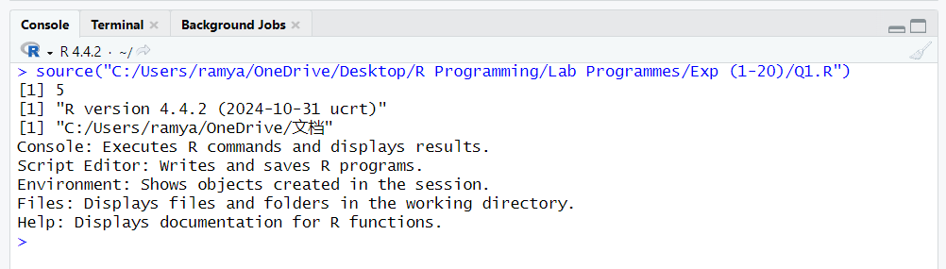
Results
The RStudio interface was explored successfully. The Console executes commands, the Script Editor is used to write programs, the Environment displays objects, the Files pane manages and browses files, and the Help pane provides function documentation. The R version and working directory were inspected.
QUESTION 2
Question
Write an R program that stores two numbers in variables and performs addition, subtraction, multiplication, ordinary division, integer division and modulus. Print each operation with a clear label so that the difference between /, %/% and %% is evident.
Aim
To perform basic arithmetic operations on two numeric variables and understand ordinary division, integer division and modulus in R.
Algorithm
- Start the R program.
- Assign two numeric values to variables a and b.
- Calculate addition, subtraction and multiplication.
- Calculate ordinary division using /.
- Calculate integer division using %/%.
- Calculate the remainder using %%.
- Print each result with a descriptive label.
Program
a <- 17
b <- 5

cat("Addition:", a + b, "\\n")
cat("Subtraction:", a - b, "\\n")
cat("Multiplication:", a * b, "\\n")
cat("Ordinary Division:", a / b, "\\n")
cat("Integer Division:", a %/% b, "\\n")
cat("Modulus (Remainder):", a %% b, "\\n")
Output
Addition: 22
Subtraction: 12
Multiplication: 85
Ordinary Division: 3.4
Integer Division: 3
Modulus (Remainder): 2
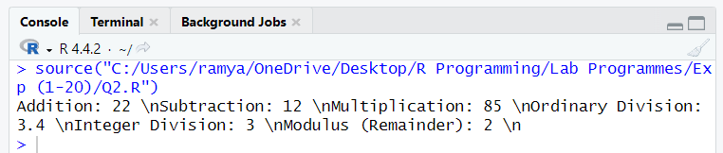
Results
The R program performed all six arithmetic operations successfully. The / operator returns the ordinary quotient, %/% returns the integer quotient, and %% returns the remainder.

QUESTION 3
Question
Create variables using the three assignment forms <-, = and ->. Assign a different numeric value with each form, print all variables, and briefly demonstrate that each form assigns a value to an object in R.
Aim
To demonstrate the three assignment operators available in R: <-, = and ->.
Algorithm
- Create a variable using the left-assignment operator <-.
- Create a second variable using the = assignment operator.
- Create a third variable using the right-assignment operator ->.
- Assign a different numeric value to each variable.
- Print all variables to verify their assigned values.
Program
first_value <- 10
second_value = 20
30 -> third_value

cat("Value assigned using <- :", first_value, "\\n")
cat("Value assigned using = :", second_value, "\\n")
cat("Value assigned using -> :", third_value, "\\n")
Output
Value assigned using <- : 10
Value assigned using = : 20
Value assigned using -> : 30
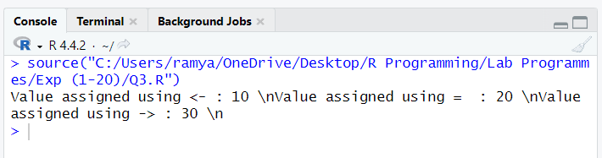
Results
All three assignment forms assigned values to their respective variables successfully. The commonly used assignment operator in R is <-, while = and -> can also assign values.

QUESTION 4
Question
Create one variable each of numeric, integer, character, logical and complex type. Use class(), typeof() and str() to inspect the variables. Display the results in a readable form and distinguish the class of an object from its underlying storage type.
Aim
To create variables of numeric, integer, character, logical and complex types and inspect their class, storage type and structure.
Algorithm
- Create one variable for each required data type.
- Use class() to identify the object's class.
- Use typeof() to identify its internal storage type.
- Use str() to display the structure of each variable.
- Print the inspection results with labels.
Program
num_value <- 12.5
int_value <- 12L
char_value <- "R Programming"
logical_value <- TRUE
complex_value <- 3 + 2i

variables <- list(
Numeric = num_value,
Integer = int_value,
Character = char_value,
Logical = logical_value,
Complex = complex_value
)

for (name in names(variables)) {
cat("\\n", name, "\\n")
cat("Class:", class(variables[[name]]), "\\n")
cat("Storage type:", typeof(variables[[name]]), "\\n")
str(variables[[name]])
}
Output
Numeric
Class: numeric
Storage type: double
num 12.5

Integer
Class: integer
Storage type: integer
int 12

Character
Class: character
Storage type: character
chr "R Programming"

Logical
Class: logical
Storage type: logical
logi TRUE

Complex
Class: complex
Storage type: complex
cplx 3+2i

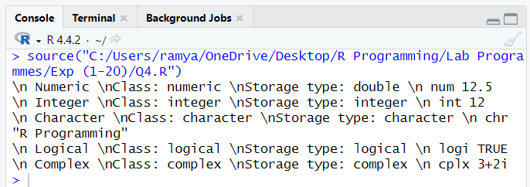
Results
Variables of all five requested data types were created and inspected. class() identifies the class, typeof() reports the underlying storage type, and str() provides a compact structural description. Numeric values are generally stored as double, whereas values marked with L are stored as integer.

QUESTION 5
Question
Create a character vector containing numeric-looking strings and one invalid numeric string. Convert it to numeric using as.numeric(), inspect the resulting values and identify any warning or NA produced by the invalid entry. Also demonstrate a suitable conversion between numeric, character and logical types.
Aim
To convert character data into numeric, character and logical forms and observe how invalid numeric text produces NA and a warning.
Algorithm
- Create a character vector containing valid numeric strings and one invalid string.
- Convert the character vector using as.numeric().
- Display the converted values and identify the NA entry.
- Convert a numeric value to character using as.character().
- Convert suitable values to logical using as.logical().
- Print all conversion results.
Program
text_values <- c("10", "25.5", "R", "40")
numeric_values <- as.numeric(text_values)

cat("Original character values:\\n")
print(text_values)
cat("Converted numeric values:\\n")
print(numeric_values)
cat("Positions converted to NA:\\n")
print(which(is.na(numeric_values)))

number <- 25
character_value <- as.character(number)
logical_values <- as.logical(c(0, 1, 5, 0))

cat("Numeric to character:", character_value, "\\n")
cat("Numeric to logical:\\n")
print(logical_values)
Output
Original character values:
[1] "10" "25.5" "R" "40"
Converted numeric values:
[1] 10.0 25.5 NA 40.0
Positions converted to NA:
[1] 3
Numeric to character: 25
[1] FALSE TRUE TRUE FALSE

A warning is generated because "R" cannot be converted to a number.
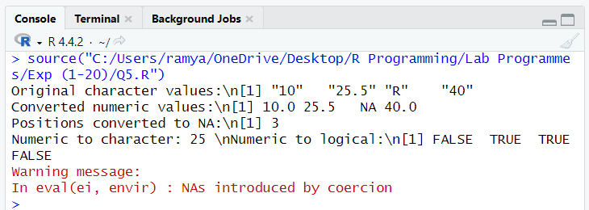
Results
The valid numeric strings were converted successfully. The invalid string "R" produced NA and a warning. Numeric-to-character and numeric-to-logical conversions were also demonstrated; zero converts to FALSE and nonzero numeric values convert to TRUE.
QUESTION 6
Question
Create a numeric vector and evaluate relational conditions such as greater than, less than, equal to and not equal to. Combine conditions with &, | and !, then print each logical vector and explain which elements satisfy the conditions.
Aim
To evaluate relational operators and combine logical conditions using &, | and ! on a numeric vector.
Algorithm
- Create a numeric vector.
- Evaluate greater-than, less-than, equal-to and not-equal-to conditions.
- Combine two conditions using the AND operator &.
- Combine conditions using the OR operator |.
- Apply the NOT operator ! to a logical condition.
- Print each logical vector.
Program
x <- c(5, 10, 15, 20, 25)

cat("Greater than 10:\\n")
print(x > 10)
cat("Less than 20:\\n")
print(x < 20)
cat("Equal to 15:\\n")
print(x == 15)
cat("Not equal to 10:\\n")
print(x != 10)
cat("AND (greater than 10 and less than 25):\\n")
print((x > 10) & (x < 25))
cat("OR (less than 10 or greater than 20):\\n")
print((x < 10) | (x > 20))
cat("NOT (not greater than 10):\\n")
print(!(x > 10))
Output
Greater than 10:
[1] FALSE FALSE TRUE TRUE TRUE
Less than 20:
[1] TRUE TRUE TRUE FALSE FALSE
Equal to 15:
[1] FALSE FALSE TRUE FALSE FALSE
Not equal to 10:
[1] TRUE FALSE TRUE TRUE TRUE
AND:
[1] FALSE FALSE TRUE TRUE FALSE
OR:
[1] FALSE FALSE FALSE FALSE TRUE
NOT:
[1] TRUE TRUE FALSE FALSE FALSE
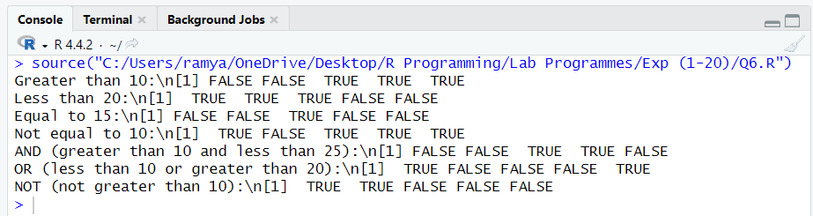
Results
Relational operators generated logical vectors correctly. The & operator returns TRUE only when both conditions are TRUE, | returns TRUE when at least one condition is TRUE, and ! reverses each logical value.
QUESTION 7
Question
Use R's built-in mathematical functions abs(), sqrt(), round(), ceiling(), floor(), log() and exp() on suitable numeric values. Print each result with a label and ensure the selected inputs demonstrate the purpose of each function.
Aim
To apply R's built-in mathematical functions to suitable numeric values and display their results.
Algorithm
- Choose suitable positive and negative numeric values.
- Apply abs() to obtain absolute values.
- Apply sqrt() to calculate square roots.
- Use round(), ceiling() and floor() for rounding operations.
- Use log() to calculate the natural logarithm of a positive value.
- Use exp() to calculate the exponential value.
- Print each result with a label.
Program
x <- -16.7
y <- 25
z <- 3.14159

cat("Absolute value:", abs(x), "\\n")
cat("Square root:", sqrt(y), "\\n")
cat("Round:", round(z, 2), "\\n")
cat("Ceiling:", ceiling(3.2), "\\n")
cat("Floor:", floor(3.8), "\\n")
cat("Natural logarithm:", log(10), "\\n")
cat("Exponential:", exp(1), "\\n")
Output
Absolute value: 16.7
Square root: 5
Round: 3.14
Ceiling: 4
Floor: 3
Natural logarithm: 2.302585
Exponential: 2.718282
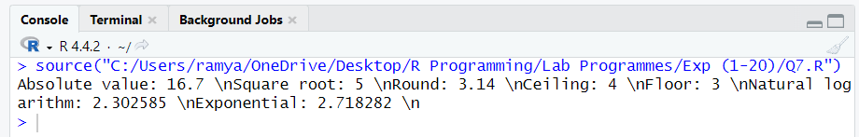
Results
The mathematical functions executed successfully. They calculated absolute value, square root, rounding, ceiling, floor, natural logarithm and the exponential function.

QUESTION 8
Question
Create a numeric vector and demonstrate positive indexing to select specified positions, negative indexing to exclude positions, and logical indexing to select values satisfying a condition. Display each selection and explain how R's one-based indexing works.
Aim
To demonstrate positive, negative and logical indexing in R and understand one-based vector indexing.
Algorithm
- Create a numeric vector.
- Use positive indices to select specified positions.
- Use negative indices to exclude specified positions.
- Use a logical condition to select matching values.
- Display all selected elements.
- Explain that R vector positions begin at 1.
Program
numbers <- c(10, 20, 30, 40, 50, 60)

cat("Original vector:\\n")
print(numbers)
cat("Positive indexing (positions 2 and 4):\\n")
print(numbers[c(2, 4)])
cat("Negative indexing (exclude positions 2 and 4):\\n")
print(numbers[-c(2, 4)])
cat("Logical indexing (values greater than 30):\\n")
print(numbers[numbers > 30])
Output
Original vector:
[1] 10 20 30 40 50 60
Positive indexing:
[1] 20 40
Negative indexing:
[1] 10 30 50 60
Logical indexing:
[1] 40 50 60
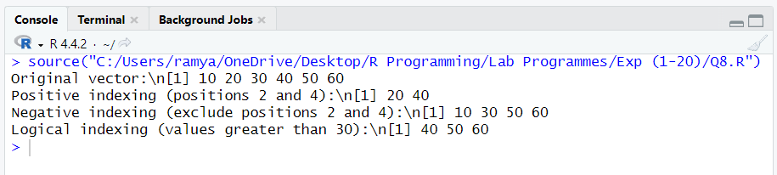
Results
Positive indexing selected the requested positions, negative indexing excluded the specified positions, and logical indexing selected values satisfying the condition. R uses one-based indexing, so the first element is at position 1.
QUESTION 9
Question
Use seq() to generate a numeric sequence with a specified start, end and increment. Use rep() to repeat individual values and a short vector. Print all results and compare the sequence-generation and repetition operations.
Aim
To generate numeric sequences using seq() and repeat values or vectors using rep().
Algorithm
- Use seq() with a start, end and increment to generate a sequence.
- Use rep() to repeat a single value a specified number of times.
- Use rep() with a vector and times to repeat the complete vector.
- Print and compare the generated results.
Program
sequence_values <- seq(from = 2, to = 10, by = 2)
repeated_value <- rep(5, times = 4)
repeated_vector <- rep(c(1, 2, 3), times = 2)

cat("Sequence using seq():\\n")
print(sequence_values)
cat("Repeated individual value:\\n")
print(repeated_value)
cat("Repeated vector:\\n")
print(repeated_vector)
Output
Sequence using seq():
[1] 2 4 6 8 10
Repeated individual value:
[1] 5 5 5 5
Repeated vector:
[1] 1 2 3 1 2 3
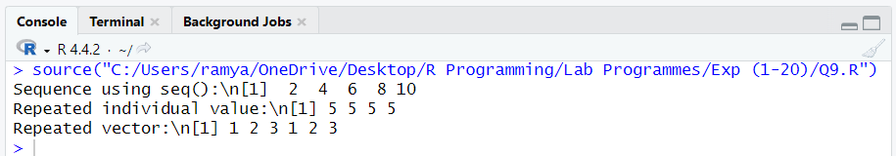
Results
seq() generated values according to the specified start, end and increment. rep() repeated a single value and a complete vector as requested.

QUESTION 10
Question
Create two numeric vectors of equal length and perform element-wise addition, subtraction, multiplication, division and comparisons. Also demonstrate vector recycling with a shorter vector, noting the result and any warning if lengths are not compatible.
Aim
To perform element-wise arithmetic and comparisons on numeric vectors and demonstrate R's vector recycling rule.
Algorithm
- Create two numeric vectors of equal length.
- Perform addition, subtraction, multiplication and division element by element.
- Compare the vectors using a relational operator.
- Create a shorter vector and combine it with a longer vector.
- Observe how R recycles the shorter vector's values.
- Print all results.
Program
a <- c(10, 20, 30, 40)
b <- c(2, 4, 5, 8)

cat("Addition:\\n"); print(a + b)
cat("Subtraction:\\n"); print(a - b)
cat("Multiplication:\\n"); print(a * b)
cat("Division:\\n"); print(a / b)
cat("Comparison (a > b):\\n"); print(a > b)

short_vector <- c(1, 2)
cat("Vector recycling (a + short_vector):\\n")
print(a + short_vector)

# A non-multiple length produces a recycling warning
long_vector <- c(1, 2, 3, 4, 5)
cat("Recycling with incompatible lengths:\\n")
print(long_vector + c(10, 20))
Output
Addition:
[1] 12 24 35 48
Subtraction:
[1] 8 16 25 32
Multiplication:
[1] 20 80 150 320
Division:
[1] 5 5 6 5
Comparison (a > b):
[1] TRUE TRUE TRUE TRUE
Vector recycling:
[1] 11 22 31 42
Incompatible-length recycling:
[1] 11 22 13 24 15
Warning: longer object length is not a multiple of shorter object length
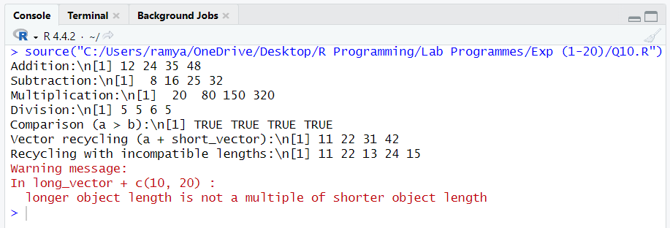
Results
Element-wise arithmetic and comparisons were performed successfully. R recycled the shorter vector to match the longer vector. When the longer length is not a multiple of the shorter length, R still performs recycling but issues a warning.

QUESTION 11
Question
Create a numeric vector containing repeated values. Calculate and display its sum, mean, median, length, minimum, maximum and range. Label each result clearly and state what information each summary provides about the data.
Aim
To calculate descriptive summary statistics for a numeric vector containing repeated values.
Algorithm
- Create a numeric vector containing repeated values.
- Calculate the sum using sum().
- Calculate the arithmetic mean using mean().
- Calculate the median using median().
- Find the number of elements using length().
- Calculate minimum, maximum and range.
- Display all statistics with labels.
Program
marks <- c(70, 80, 90, 80, 60, 100, 70)

cat("Sum:", sum(marks), "\\n")
cat("Mean:", mean(marks), "\\n")
cat("Median:", median(marks), "\\n")
cat("Length:", length(marks), "\\n")
cat("Minimum:", min(marks), "\\n")
cat("Maximum:", max(marks), "\\n")
cat("Range:", range(marks), "\\n")
Output
Sum: 550
Mean: 78.57143
Median: 80
Length: 7
Minimum: 60
Maximum: 100
Range: 60 100
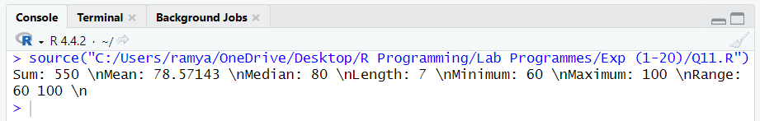
Results
The summary statistics were calculated successfully. Sum gives the total, mean gives the arithmetic average, median gives the middle value, length gives the number of observations, minimum and maximum give the extreme values, and range displays both extremes.

QUESTION 12
Question
Create a vector containing repeated and unsorted values. Use sort() to arrange the values, unique() to list distinct values, duplicated() to identify repeated occurrences, and table() to show frequencies. Display and compare the results.
Aim
To arrange vector values, identify unique and duplicated elements, and calculate the frequency of each value.
Algorithm
- Create a vector containing repeated and unsorted values.
- Use sort() to arrange the values in ascending order.
- Use unique() to obtain distinct values.
- Use duplicated() to identify repeated occurrences after the first appearance.
- Use table() to calculate frequencies.
- Print and compare the results.
Program
values <- c(4, 2, 4, 3, 2, 5, 4, 3)

cat("Original vector:\\n")
print(values)
cat("Sorted values:\\n")
print(sort(values))
cat("Unique values:\\n")
print(unique(values))
cat("Duplicated positions:\\n")
print(which(duplicated(values)))
cat("Frequency table:\\n")
print(table(values))
Output
Original vector:
[1] 4 2 4 3 2 5 4 3
Sorted values:
[1] 2 2 3 3 4 4 4 5
Unique values:
[1] 4 2 3 5
Duplicated positions:
[1] 3 5 7 8
Frequency table:
values
2 3 4 5
2 2 3 1
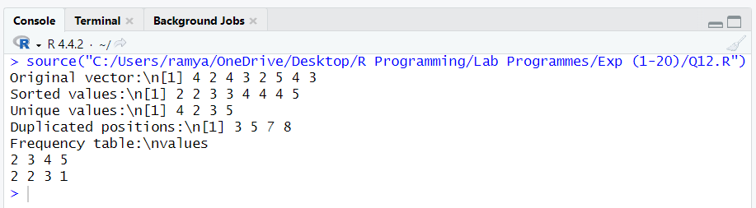
Results
The vector was sorted successfully. unique() returned distinct values, duplicated() identified repeated occurrences after their first appearance, and table() displayed the frequency of each value.

QUESTION 13
Question
Create an R list containing different data types, such as a student's name, age, marks vector and pass status. Access list elements by position and by name, update one element, and print the complete list and selected values.
Aim
To create and manipulate an R list containing elements of different data types.
Algorithm
- Create a list with a student's name, age, marks vector and pass status.
- Access an element by its position using double square brackets.
- Access an element by its name using the $ operator.
- Update the student's age.
- Print the complete list and selected elements.
Program
student <- list(
name = "Anil",
age = 20,
marks = c(85, 90, 78),
passed = TRUE
)

cat("Complete list:\\n")
print(student)
cat("Name by position:", student[[1]], "\\n")
cat("Age by name:", student$age, "\\n")
cat("Marks:\\n")
print(student[["marks"]])

student$age <- 21
cat("Updated list:\\n")
print(student)
Output
Complete list:
$name
[1] "Anil"

$age
[1] 20

$marks
[1] 85 90 78

$passed
[1] TRUE

Name by position: Anil
Age by name: 20
Marks:
[1] 85 90 78

Updated list:
$name
[1] "Anil"

$age
[1] 21

$marks
[1] 85 90 78

$passed
[1] TRUE
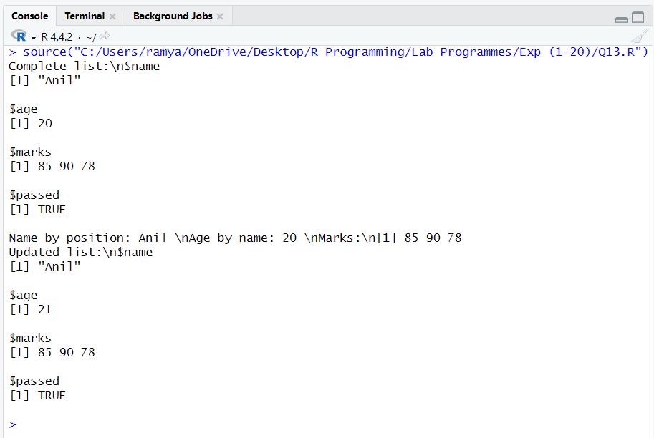
Results
A list containing character, numeric, vector and logical elements was created successfully. Elements were accessed by position and name, and the age element was updated.

QUESTION 14
Question
Create a 3×3 matrix using values from 1 to 9. Display the matrix, extract a selected row, a selected column and an individual element, and demonstrate how row and column indices identify entries in a matrix.
Aim
To create a 3×3 matrix and extract a selected row, column and individual element using row and column indices.
Algorithm
- Create a matrix containing values from 1 to 9 with three rows and three columns.
- Display the complete matrix.
- Extract the second row using row indexing.
- Extract the third column using column indexing.
- Extract the element at row 2 and column 3.
- Print the results.
Program
mat <- matrix(1:9, nrow = 3, ncol = 3)

cat("3 x 3 Matrix:\\n")
print(mat)
cat("Second row:\\n")
print(mat[2, ])
cat("Third column:\\n")
print(mat[, 3])
cat("Element at row 2, column 3:\\n")
print(mat[2, 3])
Output
3 x 3 Matrix:
[,1] [,2] [,3]
[1,] 1 4 7
[2,] 2 5 8
[3,] 3 6 9
Second row:
[1] 2 5 8
Third column:
[1] 7 8 9
Element at row 2, column 3:
[1] 8
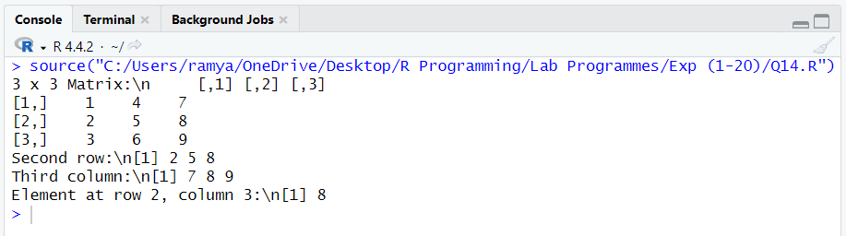

Results
The 3×3 matrix was created successfully. Row, column and individual element extraction worked correctly. In R, matrix indexing uses the form matrix[row, column].

QUESTION 15
Question
Create two compatible 2×2 matrices and perform matrix addition, subtraction, transpose and matrix multiplication. Display the original matrices and every result, distinguishing element-wise multiplication from matrix multiplication where relevant.
Aim
To perform addition, subtraction, transpose, element-wise multiplication and matrix multiplication on compatible 2×2 matrices.
Algorithm
- Create two 2×2 matrices.
- Display both matrices.
- Perform matrix addition and subtraction using + and -.
- Calculate the transpose using t().
- Perform element-wise multiplication using *.
- Perform matrix multiplication using %*%.
- Display every result.
Program
A <- matrix(c(1, 2, 3, 4), nrow = 2)
B <- matrix(c(5, 6, 7, 8), nrow = 2)

cat("Matrix A:\\n"); print(A)
cat("Matrix B:\\n"); print(B)
cat("Addition:\\n"); print(A + B)
cat("Subtraction:\\n"); print(A - B)
cat("Transpose of A:\\n"); print(t(A))
cat("Element-wise multiplication:\\n"); print(A * B)
cat("Matrix multiplication:\\n"); print(A %*% B)
Output
Matrix A:
[,1] [,2]
[1,] 1 3
[2,] 2 4
Matrix B:
[,1] [,2]
[1,] 5 7
[2,] 6 8
Addition:
[,1] [,2]
[1,] 6 10
[2,] 8 12
Subtraction:
[,1] [,2]
[1,] -4 -4
[2,] -4 -4
Transpose of A:
[,1] [,2]
[1,] 1 2
[2,] 3 4
Element-wise multiplication:
[,1] [,2]
[1,] 5 21
[2,] 12 32
Matrix multiplication:
[,1] [,2]
[1,] 23 31
[2,] 34 46
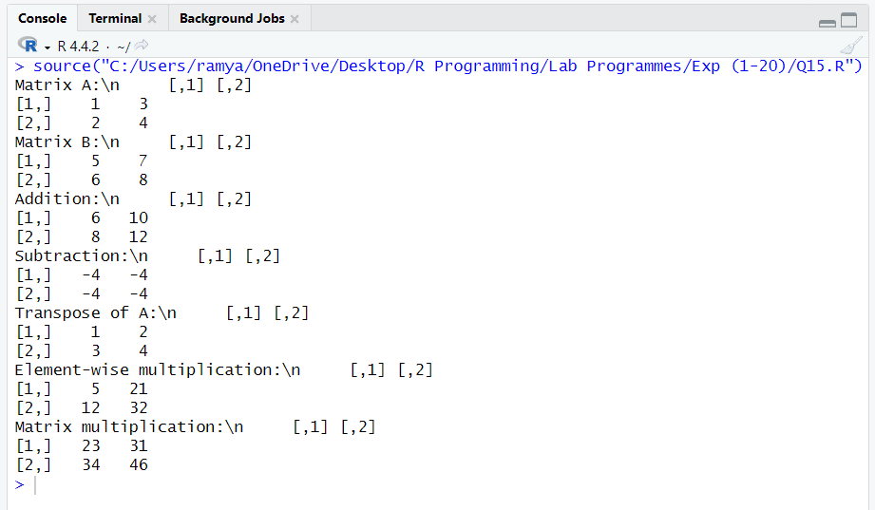
Results
Both compatible matrices were created and all requested operations were performed. The * operator multiplies corresponding elements, whereas %*% performs matrix multiplication using row-by-column products.

QUESTION 16
Question
Create a three-dimensional array containing values from 1 to 24 with dimensions 3×4×2. Display its dimensions, inspect selected elements and extract each two-dimensional slice. Explain how the dimensions organize values across the array.
Aim
To create a three-dimensional array with dimensions 3×4×2, inspect its dimensions and elements, and extract its two-dimensional slices.
Algorithm
- Generate values from 1 to 24.
- Create an array with dimensions 3, 4 and 2.
- Display the complete array and its dimensions.
- Access a selected element using three indices.
- Extract the first and second two-dimensional slices.
- Print the results.
Program
arr <- array(1:24, dim = c(3, 4, 2))

cat("Three-dimensional array:\\n")
print(arr)
cat("Dimensions:\\n")
print(dim(arr))
cat("Selected element arr[2, 3, 1]:\\n")
print(arr[2, 3, 1])
cat("First 2D slice:\\n")
print(arr[, , 1])
cat("Second 2D slice:\\n")
print(arr[, , 2])
Output
Dimensions:
[1] 3 4 2
Selected element arr[2, 3, 1]:
[1] 8
First 2D slice:
[,1] [,2] [,3] [,4]
[1,] 1 4 7 10
[2,] 2 5 8 11
[3,] 3 6 9 12
Second 2D slice:
[,1] [,2] [,3] [,4]
[1,] 13 16 19 22
[2,] 14 17 20 23
[3,] 15 18 21 24
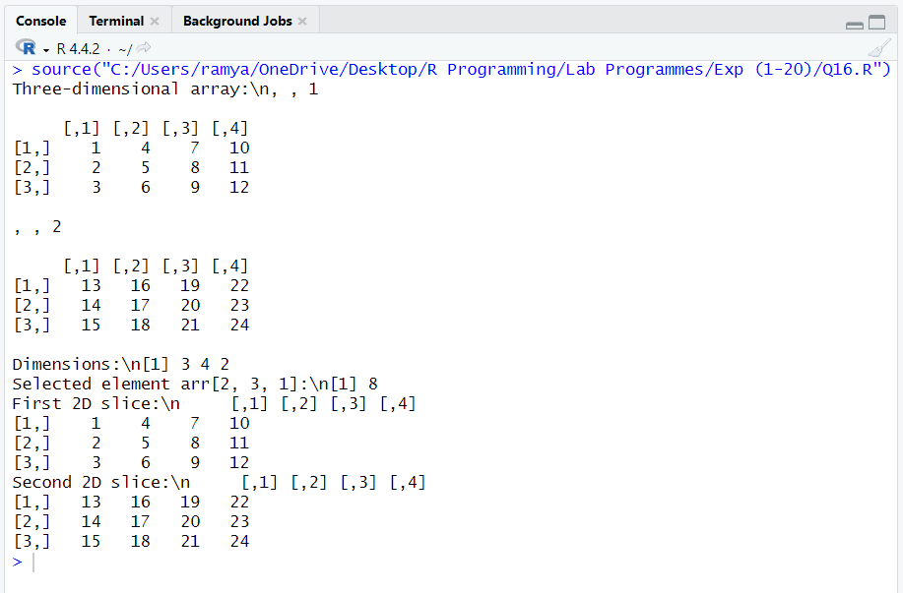
Results
A three-dimensional array containing values 1 to 24 was created with dimensions 3×4×2. The dimensions represent 3 rows, 4 columns and 2 matrix slices. Selected element access and extraction of both slices were successful.

QUESTION 17
Question
Create a factor representing ordered categories such as Low, Medium and High. Specify the level order explicitly, display the factor and its levels, and use table() to calculate category frequencies. Demonstrate why factor levels matter for ordered categorical data.
Aim
To create an ordered factor, define its levels explicitly and calculate the frequency of each category.
Algorithm
- Create a character vector containing Low, Medium and High categories.
- Convert it to a factor with levels ordered as Low, Medium and High.
- Set ordered = TRUE.
- Display the factor and its levels.
- Use table() to calculate category frequencies.
- Explain the importance of the level order.
Program
performance <- c("High", "Low", "Medium", "High",
"Low", "Medium", "High")

category <- factor(
performance,
levels = c("Low", "Medium", "High"),
ordered = TRUE
)

cat("Ordered factor:\\n")
print(category)
cat("Factor levels:\\n")
print(levels(category))
cat("Category frequencies:\\n")
print(table(category))
cat("Is High greater than Low? ", "High" > "Low", "\\n")
cat("Factor order comparison (High > Low): ",
category[1] > category[2], "\\n")
Output
Ordered factor:
[1] High Low Medium High Low Medium High
Levels: Low < Medium < High
Factor levels:
[1] "Low" "Medium" "High"
Category frequencies:
category
Low Medium High
2 2 3
Is High greater than Low? TRUE
Factor order comparison (High > Low): TRUE
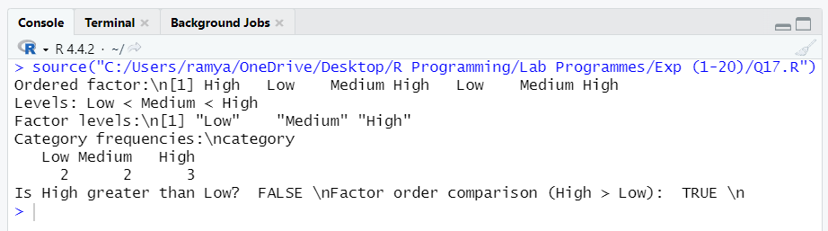
Results
An ordered factor was created successfully with levels Low < Medium < High. The frequency table counted each category. Explicit factor levels preserve the intended ordinal order for categorical analysis.

QUESTION 18
Question
Create character strings and apply nchar(), substr(), paste(), toupper() and tolower(). Display string lengths, selected substrings, concatenated text and case conversions, using clear labels for each operation.
Aim
To manipulate character strings using nchar(), substr(), paste(), toupper() and tolower().
Algorithm
- Create character strings.
- Use nchar() to calculate the number of characters.
- Use substr() to extract a selected portion of a string.
- Use paste() to concatenate strings.
- Use toupper() to convert text to uppercase.
- Use tolower() to convert text to lowercase.
- Print all results.
Program
first_name <- "Ramya"
last_name <- "Kalahasthi"
message <- "R Programming"

cat("String length:", nchar(first_name), "\\n")
cat("Substring:", substr(message, 1, 1), "\\n")
cat("Concatenated text:", paste(first_name, last_name), "\\n")
cat("Uppercase:", toupper(message), "\\n")
cat("Lowercase:", tolower(message), "\\n")
Output
String length: 9
Substring: R
Concatenated text: Ramya Kalahasthi
Uppercase: R PROGRAMMING
Lowercase: r programming
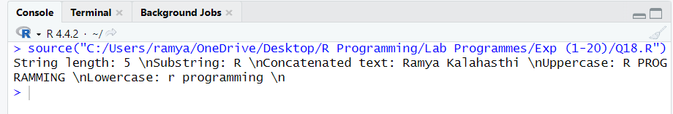
Results
The string functions were executed successfully. nchar() returned the string length, substr() extracted a substring, paste() joined text, and toupper() and tolower() changed letter case.

QUESTION 19
Question
Create Date objects from two dates in YYYY-MM-DD format. Display the dates, calculate the difference in days, and use date arithmetic to find a date a specified number of days before or after one of the given dates.
Aim
To create Date objects, calculate the difference between two dates and perform date arithmetic in R.
Algorithm
- Create two date strings in YYYY-MM-DD format.
- Convert them into Date objects using as.Date().
- Display both dates.
- Subtract the dates to calculate the difference in days.
- Add a specified number of days to one date.
- Subtract a specified number of days from one date.
- Print all results.
Program
date1 <- as.Date("2026-01-01")
date2 <- as.Date("2026-01-15")

cat("First date:", as.character(date1), "\\n")
cat("Second date:", as.character(date2), "\\n")
cat("Difference in days:", as.numeric(date2 - date1), "\\n")
cat("10 days after first date:",
as.character(date1 + 10), "\\n")
cat("5 days before second date:",
as.character(date2 - 5), "\\n")
Output
First date: 2026-01-01
Second date: 2026-01-15
Difference in days: 14
10 days after first date: 2026-01-11
5 days before second date: 2026-01-10
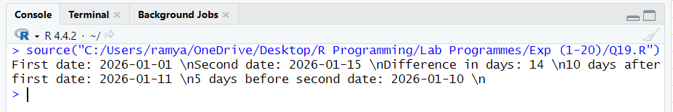
Results
The two strings were converted into Date objects. R calculated a difference of 14 days and correctly performed date addition and subtraction.

QUESTION 20
Question
Create a small student-mark dataset using a vector, matrix and list. Calculate each student's total or average as appropriate, identify the highest mark, and assemble a structured report in a list. Print the calculations and report in a readable format.
Aim
To create a student-mark dataset using vectors, a matrix and a list, calculate totals and averages, identify the highest mark, and generate a structured report.
Algorithm
- Create a vector containing student names.
- Create a marks matrix with students as rows and subjects as columns.
- Calculate each student's total and average marks.
- Identify the highest individual mark and its student.
- Create a list containing names, marks, totals, averages and the highest-mark details.
- Print the calculations and structured report.
Program
students <- c("Anil", "Bala", "Charan")
marks <- matrix(
c(80, 85, 90,
75, 88, 82,
92, 89, 95),
nrow = 3,
byrow = TRUE,
dimnames = list(students, c("Maths", "Science", "English"))
)

totals <- rowSums(marks)
averages <- rowMeans(marks)

highest_mark <- max(marks)
highest_position <- which(marks == highest_mark, arr.ind = TRUE)
highest_student <- rownames(marks)[highest_position[1, "row"]]
highest_subject <- colnames(marks)[highest_position[1, "col"]]

report <- list(
students = students,
marks = marks,
totals = totals,
averages = averages,
highest_mark = highest_mark,
highest_student = highest_student,
highest_subject = highest_subject
)

cat("Student marks matrix:\\n")
print(marks)
cat("Total marks:\\n")
print(totals)
cat("Average marks:\\n")
print(round(averages, 2))
cat("Highest mark:", highest_mark, "\\n")
cat("Student:", highest_student, "\\n")
cat("Subject:", highest_subject, "\\n")
cat("Structured report:\\n")
print(report)
Output
Student marks matrix:
Maths Science English
Anil 80 85 90
Bala 75 88 82
Charan 92 89 95

Total marks:
Anil Bala Charan
255 245 276

Average marks:
Anil Bala Charan
85.00 81.67 92.00

Highest mark: 95
Student: Charan
Subject: English
The structured report list contains the student names, marks matrix,
totals, averages, highest mark, highest-scoring student and subject.
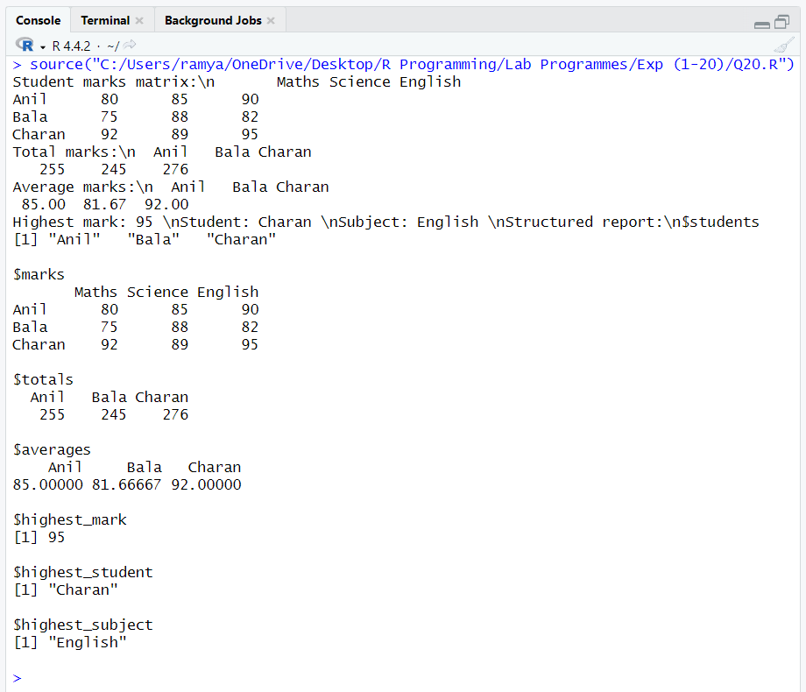
Results
The student dataset was created using a vector and matrix. Row totals and averages were calculated, and the highest individual mark was identified as 95, scored by Charan in English. All calculated information was assembled into a structured R list.

